Housing shortage? What some of the experts are saying

Short extracts from articles are below to give a flavour. Full details can be found on the links provided.
- There is no UK “housing crisis” and there never was one. Andrew Lilico, April 2015
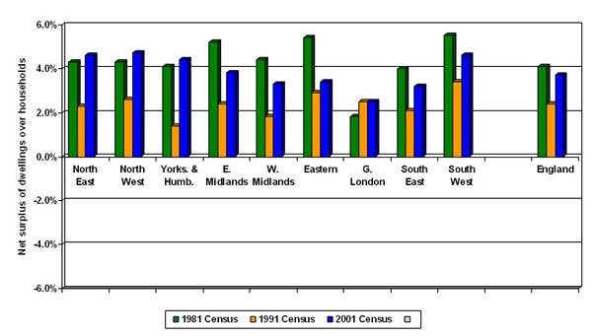

We need to continue to build more houses. And it is likely that, with accelerating population growth, the rate of new house-building in the future in the UK will need to be more rapid than it was in the recent past. But we do not have a housing shortage in England as a whole or in any region of England. High house prices are not because we have run out of houses. It’s perfectly understandable, given the data at the time, that people believed that in 2000. It’s simply refusing to look at the data if people continue to believe that now.
https://capx.co/there-is-no-uk-housing-crisis-and-there-never-was-one/

- Part 1: Is there *really* a housing shortage? Ian Mulheirn, Blog, January 2017
The best data we have shows that: the UK does have enough housing; housing costs are not high by the standards of the last 25 years, and have in fact fallen over the past decade; and additional supply, while welcome, will not have much impact on house prices or housing costs.

Before getting into the evidence, I should point out that there ‘being enough housing’ does not mean we don’t have some serious housing policy challenges. These tend to be distributional: in particular homelessness, a shortage of social housing, and much tighter restrictions on Housing Benefit for people who struggle to afford market rents. But distributional problems are separate from the macro question about overall housing supply I’m going to focus on here.

Putting all that together it’s pretty clear that the main cause of the alarm is DCLG’s household formation forecast for 2012–22. But looking at the data doesn’t give us any reason to think that we have a problem of insufficient supply.
https://medium.com/@ian.mulheirn/part-1-is-there-really-a-housing-shortage-89fdc6bac4d2

- Part 2: Are housing costs high? Ian Mulheirn, Blog, January 2017
The first post established that there doesn’t seem to be any evidence of a shortage of housing. But could spiralling costs of housing be suppressing household formation in any case? Because housing costs are spiralling, right? Well, no, it doesn’t appear so. This post looks at the evidence and shows why housing costs are not high by the standards of recent history, and have been falling on average.
https://medium.com/@ian.mulheirn/part-2-are-housing-costs-high-e6ece570c6d7

- Part 3: Why are prices so high and will building more bring them down? Ian Mulheirn, Blog, January 2017,
UK house prices are now over 150% higher in real terms than they were 20 years ago. How can such an escalation of prices have occurred if there isn’t a shortage of places to live? The answer lies in the fact that housing has a dual function: it’s a place to live but it’s also an asset that pays a return in the form of the owner occupier not having to pay rent.

If we’re worried about house price volatility, focusing on supply is a red herring. We would be better off working out how to insulate the housing market from the vicissitudes of global financial conditions.
https://medium.com/@ian.mulheirn/part-3-why-are-prices-so-high-and-will-building-more-bring-them-down-9b12dfec2720

- Number of empty homes hits highest rate for 20 years calling into question need to build on countryside. Christopher Hope, Telegraph, February 2017
Analysis of Government figures shows that there are more than one million additional homes above those required for households in the UK.
This "housing surplus" has nearly doubled from 800,000 spare homes in 1996 to 1.4million homes at any one time in 2014.
These “empty homes” are typically second homes, or vacant properties which are either left empty or are awaiting for tenants or home owners to move in.

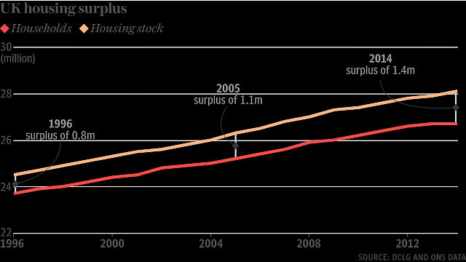
http://www.telegraph.co.uk/news/2017/02/03/number-empty-homes-hits-highest-rate-20-years-calling-question/

- Britain’s housing crisis is not what it seems. Ed Conway, The Times, October 6 2017
Developers are building as fast as they can and what’s more, they may even have built too much

Too little supply equals too few homes at crazy prices, right? Well, perhaps not. For it turns out that those demand projections may be dramatically overstating it. Official forecasts imply that the country is adding extra households at a rate of about 260,000 a year. But the reality is wildly different: household growth of only 152,000 a year since 2008. It’s quite plausible that Britain is already building enough homes to satisfy demand, maybe even too many.
From this perspective, the real problem in the housing market is not the number of homes, but the fact that people are treating them as financial assets and paying inordinate amounts for them. The growth of buy to let, the fall in interest rates, the fad for alternative investments, the gap between haves and have-nots, the flows of cheap money from around the world, the financialisation of UK housing: these are the real explanations for the housing crisis.
https://www.thetimes.co.uk/article/britain-s-housing-crisis-is-not-what-it-seems-0mz7c32lj

- Homes target may never be met, warns housing guru. Tim Wallace, Telegraph, October 2017
In a damning assessment of policy, economist Dame Kate Barker has urged the Government to come up with new policies to help buyers and renters or there will never be enough houses built to keep prices down, she said.

“The things that are likely to bring prices down relative to incomes are much much more likely to be economic difficulties, or changes in interest rates so that people couldn’t afford so much.”
http://www.telegraph.co.uk/business/2017/10/08/homes-target-may-never-met-warns-housing-guru/

- London’s housing non-shortage. Ian Mulheirn, Blog, October 13 2017
1. The number of houses has grown significantly faster than the number of households in the UK over the past 25 years;
2. The cost of housing — distinct from the price of houses — has been falling relative to prices and earnings since at least 2005.

This suggests that whatever the problems in the UK housing market – and there are real problems: sky-high prices, a lack of social housing, or falling real incomes hitting affordability thanks to the plunge in the pound — they have not been caused by a ‘chronic undersupply of housing’. In particular, since a dearth of supply cannot explain the roughly 150% real terms house prices increase over the past 20 years, it is very unlikely that the perennial wish of housing commentators to simply ‘build more houses’ will make any meaningful dent in prices, as Kate Barker recently pointed out.
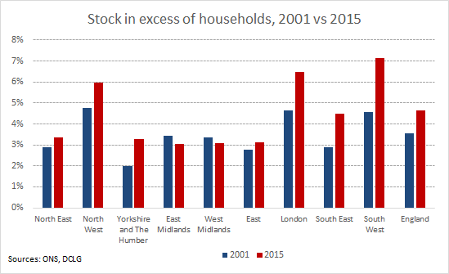
https://medium.com/@ian.mulheirn/londons-housing-non-shortage-a059593432b5

- Twitter. Ian Mulheirn, November 2017
ONS household numbers out today show 800,000 fewer than official forecasts predicted. Household formation rate running at half forecast while supply is running well above this rate #ukhousing

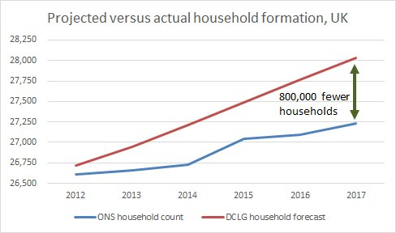
https://twitter.com/ianmulheirn/status/928296580351971329/photo/1

- Green Belt Under Siege 2017. CPRE, 2017
Based on local and city-regional planning policies and new data from planning consultants Glenigan, CPRE’s annual Green Belt Under Siege report shows that more than 70% of houses proposed for development are not expected to be ‘affordable’. It also demonstrates that just 16% of houses built on Green Belt land since 2009 outside local plans were classed as ‘affordable’.

- If we’re serious about helping young buyers, hard choices lie ahead. The Times, John Smith, November 2017
Don’t we all know what the problem is? There are too few houses and they cost too much, locking young people out of the housing market. As ever, it’s not quite that simple. The number of homes has been rising at least as fast as the population for quite a long time and if anything faster than the number of households. Looking at the aggregate numbers of homes and households, it is pretty hard to make a case that there is a growing housing shortage.
https://www.thetimes.co.uk/article/if-were-serious-about-helping-young-homebuyers-hard-choices-lie-ahead-vpnw59jc7

- How to find a housing shortage… in three misleading charts. Ian Mulheirn, Blog, 18 December 2017
MP Chris Philp has penned a monograph for the Centre for Policy Studies on what’s behind the housing crisis. You guessed it, he concludes it’s a lack of supply. It’s a clearly-argued piece, drawing on many of the same data sources as various recent parliamentary reports and the housing white paper from earlier this year. As such it is a textbook rehearsal of the usual ‘housing supply crisis’ case.

Unfortunately the data used in each step of the argument is a mixture of the partial and the just plain wrong. If we use the right data, which I present below, the picture is reversed and the premise of the housing shortage mantra falls apart.

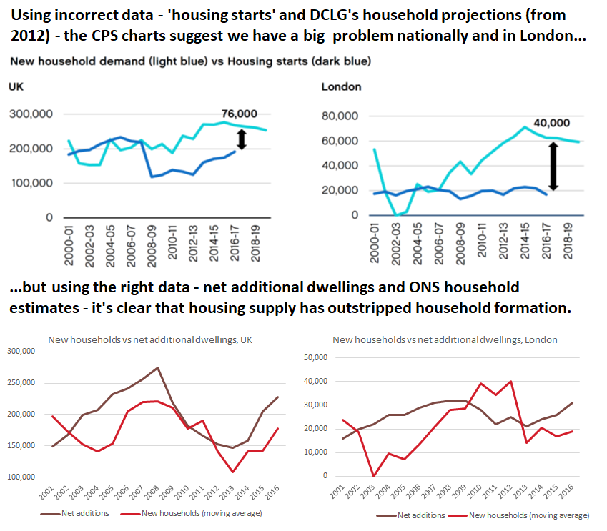
https://medium.com/@ian.mulheirn/how-to-find-a-housing-shortage-in-three-misleading-charts-2ee5ba5d3c38

- Fixing our broken housing crystal ball. Ian Mulheirn, Blog, 22 January 2018
In this blog I look at where numbers like this have come from, and why they’ve been persistently wrong. In the next blog I then re-forecast the household projections correcting for the source of those errors.

But don’t just take my word for it. In light of this less-than-impressive history of household forecasting, the methodology is about to get a shake-up. The ONS has wisely proposed to ditch the ancient history, and simply use 2001–2011 trends in household size when it takes over responsibility for producing the official household projections later this year.
There’s also been another important change that should cause us to rethink the current DCLG household projections. Last October the ONS revised down its UK population projection substantially, with England’s population in 2031 expected to be over one million people smaller than previously anticipated.

These two changes have big implications for our view of future housing need. In the next blog I’ll show what happens when we re-forecast household formation using the same DCLG method, while changing just these two crucial input assumptions. The results are stark.
https://medium.com/@ian.mulheirn/fixing-our-broken-housing-crystal-ball-6d6405963e0

- Why building more homes will not solve Britain’s housing crisis. Ann Pettifor, Guardian, 27 January 2018
Everyone – from the government, to housing charities, to housebuilders – has bought into the conventional wisdom that the dysfunction that racks our housing market is a matter of demand and supply. We’re not building enough houses, so house prices have been sent rocketing, taking home-ownership out of reach for growing numbers of young people. But in reality, our housing problems are not a simple feature of supply and demand. …
… It’s speculation in the property market that is fuelling stratospheric house price rises, not shortage of supply. When the “fuel” of private capital, mortgage credit and cash from the bank of mum and dad is supplemented by government subsidies and tax breaks, house prices rise. Moreover, wealthy global and non-resident buyers have funnelled more than £100bn into London property over recent years, making the problem even worse.
So, rather counterintuitively, building more houses is not the right prescription. House prices won’t fall until the tide of cash flowing into the market abates, for example by tightening mortgage credit, or shrinking the pool of buy-to-let investors. That may already be starting to happen as real incomes continue to fall, the Bank of England toughens up buy-to-let mortgages, and stamp duty rises are phased in for second properties….
https://www.theguardian.com/commentisfree/2018/jan/27/building-homes-britain-housing-crisis
- Mission: Unnecessary. Ian Mulheirn, Blog, 30 January 2018
Household formation in England looks set to run at about 150,000 per year up to 2031, well below current official projections.
The prime minister has described it as her ‘personal mission’ to solve the housing crisis by building more. And according to the chancellor, we need 300,000 new houses per year. To many this sounds like Mission Impossible; in fact it’s Mission Unnecessary.

My last blog told the story of why the official projections — the bedrock of the housing need figures — keep overestimating the rate of household formation. In this blog I recalculate the projections to try to correct the source of error. The results suggest that housing need is well below what the government thinks.
Modification 1 — use the latest ONS population projections
The first change I make here is to feed in ONS’s latest population forecasts, which came out last October. DCLG’s current household projections rely on ONS population projections from 2014. But the recent figures from the ONS suggest that there will be one million fewer people in England in 2031 than previously expected. (Incidentally, the primary drivers of the change are half-a-million fewer births and almost 400,000 more deaths than expected.) Naturally, all this takes a chunk out of housing need.
Modification 2 — adopt the ONS proposal on household size trends
DCLG currently bases its projections on household size trends from 1971 to 2011. As I outlined in the last blog, for much of that period households were shrinking. Since 2001 that trend has stalled, but DCLG implicitly assumes it will resume — the source of repeated over-estimates.
The ONS will take over responsibility for producing household forecasts later this year. In its consultation on the methodology, the ONS proposed to base its projections on household size trends only since 2001. While the ONS is yet to announce what it will actually do, this seems like a sensible way to address the past problems.
Re-estimating the household size projections
In re-estimating the most recent DCLG household projections to account for these two changes, I use a simplified version of their methodology, basing it on household size trends by age band.* Average household size by age is reasonably constant over time in this new projection. But older people are more likely to live in one-person households. With increasing numbers of people in the older age bands as the population ages, average household size resumes its decline in my projection, albeit at a slower rate than current official projections. The chart below shows the resulting projection (green line) grafted onto the 2017 ONS estimate for current household size.**
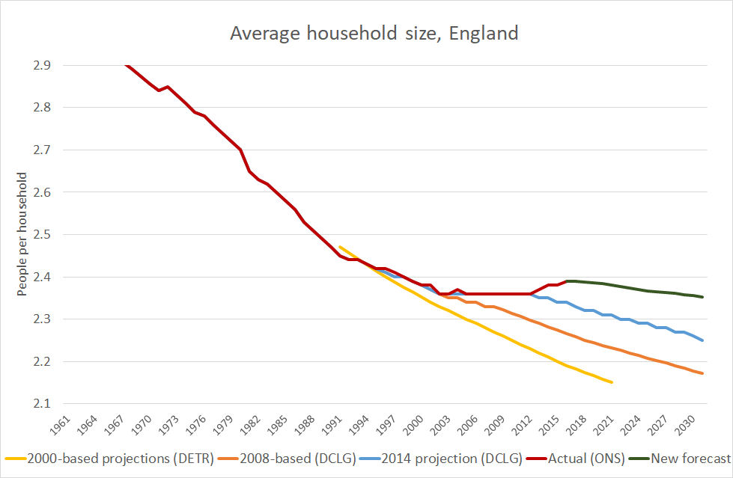
Household formation 30% lower
Combining the revised household size projections with the new population figures has a big impact on the outlook for household formation. By my calculation, adopting the ONS’s suggestion on household size trends cuts the rate of household formation by around 40,000 per year up to 2031. Meanwhile the lower population projection cuts household growth by a further 27,000 per year over the same period. The result is annual household formation running at around 151,000, rather than the current official figure of 218,000 — a 30% drop. This compares to an average household formation rate of about 140,000 per year over the past 20 years.
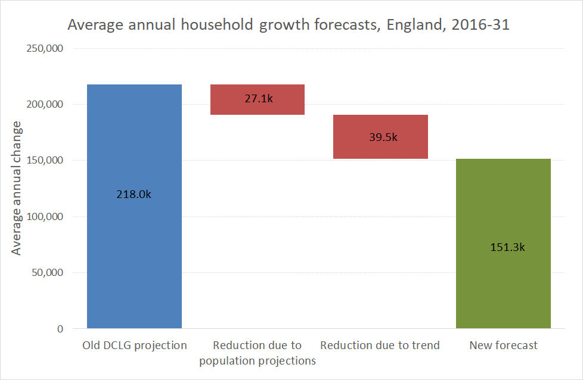
What does this mean for how many houses we need? It’s reasonable to think of housing ‘need’ as exceeding the rate of household formation. Alan Holmans, for example, suggested that in order to maintain the proportion of vacant and second homes, a extra 19,000 houses would be required each year. Adopting Holmans’ estimate, my projection implies a total housing need of around 170,000 per year up to 2031.
When the ONS decides on its approach later this year, the new projection may look something like this. Or they may make other changes so it looks higher or lower. Either way, tweaking the current approach in the ways they have indicated yields a more plausible, but significantly lower, projection than policy is currently based on.
And there’s nothing wrong with erring on the side of caution and shooting higher with the targets. Hell, let’s throw in another 30,000 houses per year in case household formation turns out higher. But let’s not panic that we ‘need’ any more than 200,000 per year to accommodate new households and keep housing costs under control.
*I have used a simplified version of the method documented by DCLG. I use DCLG’s ‘headship rate’ data, replacing the post-2011 trend given with a continuation of the trend from 2001–11. In keeping with the DCLG methodology, these headship rates are then multiplied by projections of the household population. This is derived from the ONS’s latest population projections by age group, less DCLG’s estimates of the number of people living in institutions. This process is completed for headship rates and household population by age band. Building it up in this way, rather than simply projecting forwards the average household size trend, allows the projection to capture the fact that, even if headship rates by age are constant, average household size may still fall if the population ages, since older people are more likely to live alone. In its more granular methodology DCLG breaks down trends by age, sex and marital status. For these purposes, however, the age-based break-down is likely (in my view) to be the most important one because the ageing population is probably the single most important determinant of the average household size trend.
**This projection is probably conservative because it assumes that the recent up-tick in household size, seen in the ONS’s surveys, immediately goes into reverse from next year, and a downward trend resumes. We might doubt that, since the recent drift upwards appears to have been due to a bigger migrant population, and the LFS suggests that migrants tend to live in larger households. Consequently this projection may continue to over-estimate household formation.
https://medium.com/@ian.mulheirn/mission-unnecessary-66feebd5b469
- Why has home ownership collapsed. Ian Mulheirn, Blog, 27 Feb 2018
A simple question with a not-so-obvious answer.
Last week the IFS produced a report that documented the dramatic collapse in home ownership among young adults. The report concludes that rapid house price growth since 1996 was the cause. But this blog argues that the main driver was actually the sudden change in credit conditions for first-time buyers in the wake of the financial crisis. This explanation points to a very different set of policy options if we want to recover the high home ownership rates of the early 2000s.
- Home ownership fell most while prices were falling
- Home ownership fell similarly in all regions despite divergent price trends
The major cause: a first-time buyer mortgage drought
Policy implications
Once we realise that the home ownership rate depends critically on the availability and cost of mortgages for FTBs relative to those for other would-be buyers (implicitly buy-to-let), different policy options emerge. The good news is there are three broad options. The bad news is that none of them are politically easy.

• Privatise the risk again. One option is to end the limits on high loan-to-income loans, and relax mortgage affordability tests. That might allow the average would-be home owner to buy sooner, driving up home ownership. But in light of the financial crisis, those limits and constraints have been introduced for good reasons and it would be a bold politician who recommend allowing the banking sector to assume lots risk again as a way to push home ownership back up.
• Publicly subsidise the risk (more). If you’re not too impressed with the private sector’s risk-management track record of late, an alternative way to raise home ownership would be to use taxpayers’ money to subsidise it. Re-introducing MIRAS (mortgage interest relief at source), the direct mortgage interest subsidy introduced in 1983 to boost home ownership and abolished in 2000, would be one option. Or we could extend George Osborne’s Help to Buy schemes — almost a covert version of MIRAS — where the taxpayer took on £12bn of contingent liabilities. For all its detractors, Help to Buy almost certainly helped to break the fall in home ownership.
Politicians of almost every stripe support the goal of raising home ownership. But rather than letting them peddle bogus solutions like increasing housing supply, we should ask them to clarify who they would have pay to make that happen. Or, of course, there is a third option:
• Give up on achieving 70% home ownership. If neither of the above seem acceptable, then we may have to acknowledge that the 71% home ownership rate of the early 2000s is a thing of the past and accept that something nearer the current 63% is here to stay. If the private rented sector was more secure and attractive, might this be the most politically palatable choice?
https://medium.com/@ian.mulheirn/why-has-home-ownership-collapsed-764c242eaf92

